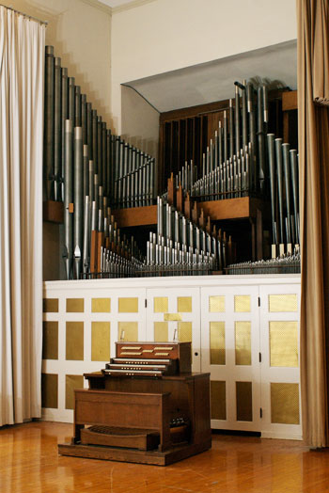
Memorial Hall

University of Kentucky, Lexington, KY
Holtkamp Organ Company,
Cleveland, Ohio, 1952
3 Manuals/52 ranks

POSITIV ORGAN-Man. I
Copula 8’
Quintadena 8’
Spitzflote 4’
Nazard 2-2/3’
Principal 2’
Tierce 1-3/5’
Scharff III
Cromorne 8’

GREAT ORGAN–Man.II
Quintadena 16’
Principal 8’
Spillflote 8’
Octave 4’
Rohrflote 4’
Doublette 2’
Sifflote 1’
Rauschquinte II
Mixture IV
Trumpet 8’
Chimes

SWELL ORGAN-Man. III
Flute A’cheminee 8’
Gamba 8’
Voix Celeste 8’
Octave Geigen 4’
Gemshorn4’
Blockflote 2’
Sesquialtera II
Larigot 1-1/3’
Fagot 8’
Schalmey 4’
Tremolo

PEDAL ORGAN
Contrabass 16’
Sub Bass 16’
Quintadena 16’ (Gt)
Grossquinte 10-2/3’
Octave 8’
Gedackt 8’
Choralbass 4’
Nachthorn 2’
Mixture III
Posaune 16’
Trumpet 8’
Bassoon 8’
Oboe Clarion 4’

Combination Action
6 General Pistons(thumb and toe),
5 Swell Divisional Pistons
4 Great Divisional Pistons
3 Positiv Divisional Pistons
5 Pedal Divisional Pistons
1 level of memory

Couplers
Great to Pedal
Swell to Pedal
Positiv to Pedal
Swell to Great
Positiv to Great
Swell to Positiv

https://finearts.uky.edu/music/pipe-organs-uk

