University of Kentucky, Lexington
Flentrop Orgelbouw, Zaandam, Holland 1974
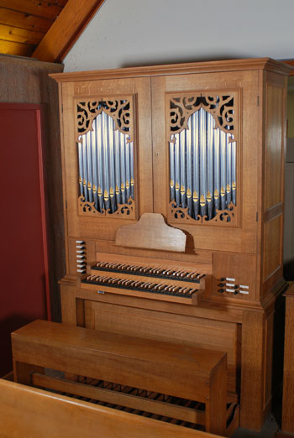
9 stops, 8 ranks
“The Flentrop organ was originally on loan to Trinity Cathedral, Cleveland, Ohio. It was purchased by Warren Wilson College, Asheville, NC in 1977 for a new music facility. In 2003 it was secured by the University of Kentucky through a major research grant fund award for the Organ Department.” https://finearts.uky.edu/music/pipe-organs-uk

Manual I
Gedekt 8’
Prestant 4’
Octaaf 2’

Manual II
Gedekt 8’ (Duplex)
Fluit 4’
Larigot 1-1/3’
Terts 1-3/5

Pedal
Gedekt 8’
Quintadeen 4’

Couplers
I + II
P + I
P + II

